**EXERCISE: 10**

**DATE: 23.11.2020**

**AIM:**

To write a Python function those accepts a string and calculate the number of upper-case latters and lower-case letters.

**PROGRAM:**

**def string_test(s):**

**d={"UPPER_CASE":0, "LOWER_CASE":0}**

**for i in range(len(s)):**

**if(s[i].isupper()):**

**d["UPPER_CASE"]+=1**

**elif(s[i].islower()):**

**d["LOWER_CASE"]+=1**

**print("No. of Upper case characters:",d["UPPER_CASE"])**

**print("No. of Lower case characters:",d["LOWER_CASE"])**

**s=input()**

**p=string_test(s)**

**LINK:**

[**http://103.53.53.18/mod/vpl/forms/submissionview.php?id=325&userid=1664**](http://103.53.53.18/mod/vpl/forms/submissionview.php?id=325&userid=1664)

**OUTPUT:**

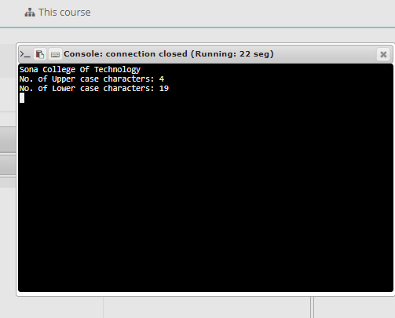

**RESULT:**

The number of upper-case and lower-case are calculated and displayed.